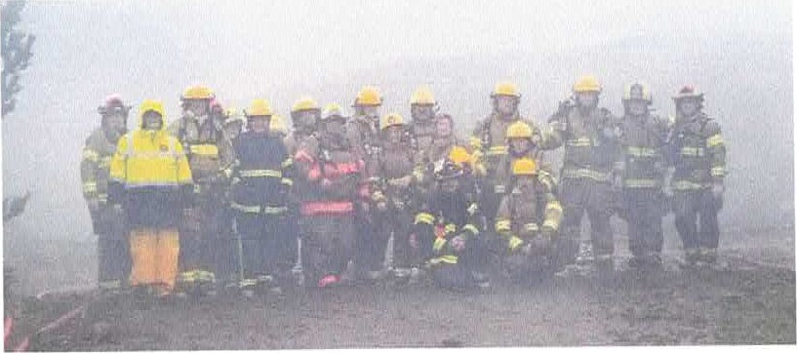

11/15/24



Seal Rock Rural Fire District thanks you for approving the levy to fund volunteer equipment and disaster preparedness.

Our 40 plus strong volunteer program has saved the district well over $750,000 per year over an equivalent full time paid staff.

The three newly elected 2021 board members hired our Chief, Will Ewin in late 2021. Shortly thereafter, Joe Munger was hired and promoted to Captain. The board mandated both to recruit volunteers, with a goal of at least 20.

They met and exceeded that mandate very quickly.

In the meantime, the new board reformed the budget and instituted checks and balances to insure accurate and prompt payments of our bills and stay within our means. We rectified the lack of maintenance and embarked on a "all hand on deck" approach to right the ship.

The volunteers were integral to this process.

We knew that the future depended on volunteers. This new levy gives us a leg up to outfit all these volunteers and control our budget after it expires.

We want to thank our Chief and Captain, both of whom took the board mandate and exceeded it more than we could have imaged with trained and qualified volunteers.

We owe a debt of gratitude to our residents. We know that not only is the district budget stretched, your budgets are too!

We pledge to spend your hard-earned money that you have entrusted to us both efficiently and wisely.

You can track the spending on our website as well as regular updates via social media.

You are always welcome at our monthly meetings as well as either firehouse in the district.

Paul Rimola

Treasurer

Seal Rock Rural Fire Protection District.